System Test Plan
Intelligent Work Management

Presented to:

Beth Giurelli

February 14, 2011

Chris Duffy, Sean Williams
407-299-3900
MasterLink Corporation
3649 All American Boulevard Orlando, Florida 32810


Contents
1. Introduction 3
1.1. Introduction to Intelligent Work Management 3
2. Test Items 4
2.1. Software Features to Be Tested 4
2.2. Software Features Not to Be Tested 4
3. Approach 5
3.1. System Test Phases 5
3.2. Item Pass/Fail Criteria and Actions 7
3.3. Test Execution Suspension and Resumption Requirements 7
3.4. System Test Exit Criteria 7
3.5. Testing the IWM Scheduler Agent 7
4. Error Management 9
4.1. The Defect Resolution Process 9
4.2. Defect Logging 10
5. Testing Artifacts 12
5.1. Testing Documentation 12
5.2. Test cases 12
5.3. Test Automation Scripts 13
5.4. Test Results within the Selenium IDE 14
5.5. Test Results in Continuous Integration Tool 15
6. Tools and Environment 16
6.1. Test Environment 16
6.2. Document revision control and defect tracking 16
6.3. Test Scripting Tool: Selenium 16
6.4. Test Script Revision Control: Subversion 17
6.5. Continuous Integration Tool: Hudson 17
7. Responsibilities 19
7.1. Roles and Responsibilities 19
8. Schedule 20
8.1. Testing Schedule 20
9. Risks and Mitigation 21
10. Approvals 22

Introduction
This document describes the system test plan for the TO12 Sonalysts project. Items covered within include information on which specific items will and will not be included in the test, as well as the complete testing process. The project will have three levels of testing, Unit, System/Integration and Acceptance. The details for each level are addressed in the approach section and will be further defined in the level specific plans. System testing and acceptance testing is to be done following each development cycle.

The test plan also includes tools and procedures that will be used throughout the course of the plan. Some tools, specifically detailed, will be included in the continual testing effort of the software post implementation. The test plan contains a list of responsibilities attached to certain individual groups involved, as well as a time table (project plan) displaying the estimated time for the projects to be completed.

Introduction to Intelligent Work Management
Intelligent Work Management (IWM) is a decision support tool for planning work, scheduling and assigning work to workers, and tracking work state. IWM keeps track of all work, preventative and corrective, and collects data such as worker feedback. This information can be used to identify areas for process improvement. Changes to policy can be implemented and enforced via IWM, creating a continuous improvement cycle.

This project focuses on improving IWM from the current version, and tailoring it to the needs of the MRAP program.

Test Items

Software Features to Be Tested
Testing will include all end user functionality and interfaces, including presentation, persistence, and reporting.

IWM also includes decision support software agents. These agents will be tested via unit tests, integration, and system testing.

If this project continues beyond the current contract, the system may include interfaces to other Marines systems, via web services. External system interfaces such as web services are included in testing at that time.

Software Features Not to Be Tested
Agent logic cannot be tested through the user interface. Unit and component level testing is done to manually verify the functions and logic of the agents.

Agent test support through the user interface, e.g. viewing test results, allows verification of those results. To the extent test results are saved to the repository in the course of an agent test, the user interface may function as part of that test.

Approach
The testing of IWM consists of unit, integration, system, and acceptance testing efforts.

- Unit testing is done by the developer and approved by the development team leader.

- Integration testing is performed automatically by the continuous integration tool.

- System Testing is done by the test manager and development team leader with assistance from the individual developers as required.

- It is unlikely in this contract that Acceptance Testing will be a part of the approved activities by the customer. When Acceptance Testing does occur, likely beyond the scope of this contract, it will performed by the end users with the assistance of the test manager and development team leader. The system enters into Acceptance test after all critical and major defects have been corrected. The system may have one major defect as long as it does not impede testing of the program, i.e. there is a work around for the error. Prior to final completion of acceptance testing all open critical and major defects must be corrected and verified by the customer test representative.

Configuration Management/Change Control - Movement from the development to test systems is controlled through the existing configuration management system, e.g. Subversion. This ensures that the source under development and the source in full test have the same version controls and tracking of changes. The same process is followed to migrate the current build from the test system to the production system once all testing has been completed according to published plans and guidelines.

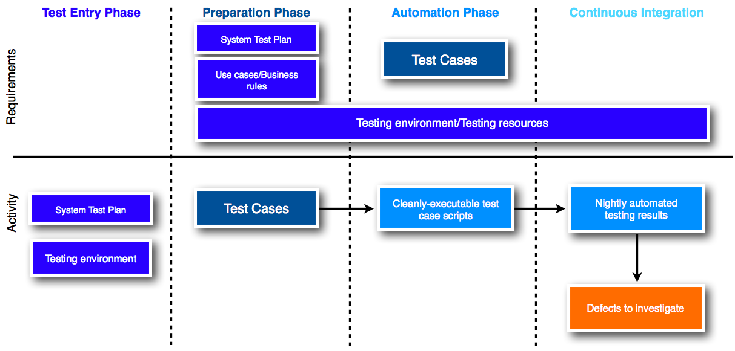
System Test Phases
Figure 1: System Test Phases

Test Entry Phase
The Test Entry phase is used to create the documentation and test environment. The test environment is described in section 6, Tools and Environment.

The System Test Plan (this document) must be completed and approved during this phase.

Preparation Phase
Test preparation of individual components and functionality begins as soon as possible following a functional requirement definition. Once a requirement has been identified and well defined, test case preparation can begin.

Test cases are derived from the end-to-end scenarios of the use cases, with variations created that describe the alternate flow/exceptions, as well as boundary cases identified from the data for the use case defined in the business rule. Each test case defines the steps a user would take to accomplish a certain goal in an 'action-response' based scheme. Test cases are organized by functional area and documented on the IWM development wiki, which also houses the defect tracking system.

Test case development occurs in tandem with development requirement documentation. As new requirements are identified and documented, new test cases will be created. Once an individual test case or set of cases in a functional area has been defined and documented, it is ready to move to the Automation Phase.

Automation Phase
The Automation Phase focuses on turning the textual test cases created in the Preparation Phase into executable, repeatable tests. In this phase, test scripts are created for each test case.

Test cases are translated into scripts which execute during the automated build/test process. These scripts are saved and versioned with references to the test cases they automate. The work of the Automation Phase consists of the creation of these automated test scripts and integrating them into the build/test environment.

A test case (or group of cases in a functional area) is ready to move to the Continuous Integration Phase when a test cases’ scripts can be executed reliably in an automated fashion, with logging of pass or fail result.

Continuous Integration Phase
The testing server is configured to automatically perform the nightly and weekly builds, and report build/test failures. Upon successful build, the testing server runs all unit tests and automated test scripts, and saves browser-accessible reports of build and test results. These functions are performed by Hudson, the continuous integration tool described in section 6.5.

Test failures are identified via the test results, and manually investigated using the test case, script, and test results.

Item Pass/Fail Criteria and Actions
A test is considered to pass when each step in the test case executes without error, and the test results match the test cases expected results. If the test is unable to execute, aborts execution mid-run, or fails to match any expected result, it has failed.

If a test passes, no further action is necessary. All tests, even those that pass, will be automatically executed again following the next build in order to regression test functionality and validate no new defects were created due to code/configuration changes.

If a test fails, the test case gets reported and resolved using the defect resolution process. See section 4.1 The Defect Resolution Process.

Test Execution Suspension and Resumption Requirements
In the event of a major or unexpected requirements or scope change, testing will be suspended. The goal of test suspension is to maintain test integrity by ensuring that the test cases and scripts match all current and new requirements.

Each test case which may be affected with respect to the new requirements/scope is reviewed to determine the impact. Once the test cases have been reviewed and any updates made, subsequent changes are made to the associated automated test scripts. Automated testing resumes when all the test cases have been reviewed and updated, and all associated test scripts have been updated.

System Test Exit Criteria
System testing concludes when:
- All test cases have been executed
- There are no defects with severity Critical
- There are less than 5 defects with severity High
- Any defects with a severity of High are well documented and include a resolution strategy

See section 4.2 for definition of defect severity levels.

Testing the IWM Scheduler Agent
The IWM Scheduler agent is a stand-alone component with no user interface screens, testing the Scheduler is done separately from the web application system testing.

Testing the IWM Scheduler agent begins with the developer writing a set of unit tests that test the correctness of the classes, methods, and other functions that make up the scheduler. This testing ensures that the code does what the developer intended.

The next level of testing is at the scheduler component level. Here, the testing consists of a set of scenarios, captured as XML documents that represent the core scheduling/assignment choices and decisions that the scheduler must make correctly. This level of testing is oriented towards both the correctness of the scheduler - it may not produce illegal schedules, assign resources that are not qualified or do not have the time to be put on a given job - and the optimizations done by the scheduler. The latter is much harder to test, as there may not be an obvious “right answer”; that is, the schedule of maximal utility is not known in closed form for all but the simplest scheduling cases.

Note also that some of the algorithms under development are stochastic searches; these algorithms have an element of randomness built into them. Testing of these algorithms may require the tester to capture the random number sequence used by the algorithms.

Development of a new version of the scheduler begins by testing the new code against the current scheduler to make sure that the schedules produced by the new scheduler are “in the ballpark” of those produced by the old scheduler, e.g. it’s not doing anything resulting in schedules of lower utility. Once this baseline is established, then additional modifications to the new scheduler would make it increasingly less useful to run against the old scheduler, and hence the need to go forward w/ testing v. the Comet scheduler.

Part of the development of the scheduler is the process of porting from the design-level language (COMET) to the implementation level language (Java). This process will use a running prototype as an example of the “correct” answer in the sense that the Java implementation should mimic the utility calculations done by the COMET version.

As the scheduler is improved, the answers obtained using an earlier version of the scheduler will not be the target goal for the next level of improvement. That is, a more sophisticated algorithm will define a schedule that is of higher utility than an older, less sophisticated algorithm. Thus, any regression testing of the new version of the scheduler must take into account that the schedules it produces may vary from the previous version, in the direction of increasing the level of utility of the schedules produced.

Error Management
This section describes the procedures used to track and resolve errors which crop up during the course of testing the system.

The Defect Resolution Process
The defect resolution process follows the steps below:

- A defect is identified.
- A ticket for the defect is entered in Trac, with a status of NEW
- The ticket is assigned to a developer. Status is now ASSIGNED.
- The assigned developer recreates the defect to determine legitimacy.
- A legitimate defect may be deferred under some conditions, such as applicability to current project goals. If it is deferred, it is archived for future reference.
- When the developer begins working on a fix for the defect, the ticket is marked OPEN to indicate it is a work in progress.
- When the developer completes and commits a fix to version control, the ticket is automatically marked FIXED by Trac, using triggers in the commit comments.
- Trac automatically reassigns the ticket to the tester who created the ticket. The tester, upon accepting the assignment, changes the state to TEST.
- The tester retests the defect to verify the committed fix correctly addressed the defect.
- Upon successful retest, the ticket is marked CLOSED and archived.
- If the retest fails, the ticket is marked REOPEN and is reassigned to a developer.

In addition there are specific work flows to handle duplicate tickets, defects rejected by the development team, and tickets created in error. A high-level overview of the defect resolution process is shown in Figure 2: Defect resolution process.
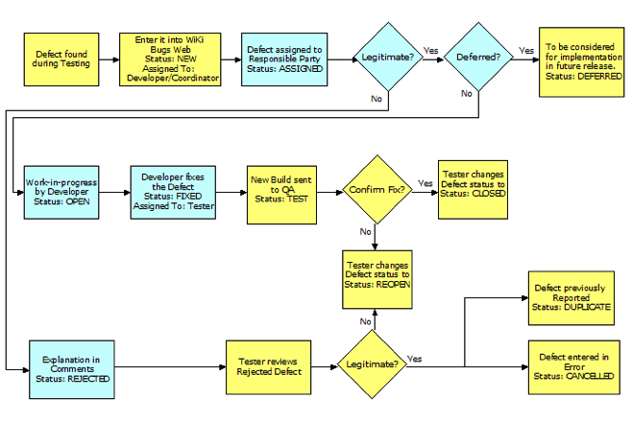

Figure 2: The Defect Resolution Process

Defect Logging
Defects are entered into the project defect-tracking tool as they are identified through testing. Below are the classifications that identify the ticket for filtering in addition to the description that is given by the author of the ticket.

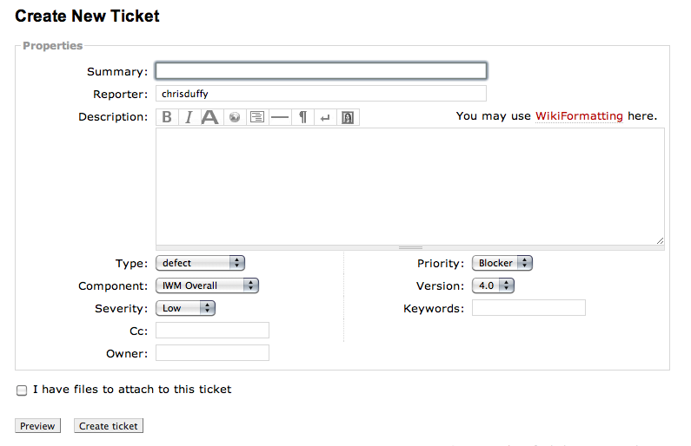
Figure 3: Trac Ticket Interface

Trac Ticket Fields

Type
- Defect – Situations that occur when the IWM system itself does not respond in the appropriate manner or yields an unexpected or undesired result.
- Enhancement – Changes in the system that would otherwise be termed as upgrades.

Component
- Agents
- IWM Overall
- Screens

Severity
- Low - Issue or defect has little impact on the project. Minor or “cosmetic” changes that need to be made.
- High - Issue or defect that severely impedes the progress of the test. Does not totally suspend its execution, although could threaten the completion of a key deliverable. A Workaround exists.
- Critical - Issue or defect that has a major impact on the overall project in terms of time, cost, resources, scope or customer acceptance. Must be brought to the development team for immediate review and resolution. The application cannot perform core functionality until the item is fixed. The defect has major impact on the ability to complete a phase of the project or a key deliverable. Significantly impacts the deployment of the system, usability of the application, or a major component is disabled. The application produces incorrect results, and no workaround exists.

Priority
- Trivial – The issue may remain unresolved for an extended length of time and may even be a problem that the system will correct on its own.
- Minor - The issue may remain unresolved for an extended length of time, however it is an issue that requires attention.
- Major – The issue requires immediate attention and may be hindering to the continuation of the testing to some degree.
- Blocker – The issue requires immediate attention and is hindering to the continuation of the testing and the functionality of the system.

Testing Artifacts
This section describes the documents and other materials produced as part of the testing effort

Testing Documentation

- The System Test Plan, this document, describes the approach, methods, tools and processes used to test the components and functionality of the system.

- The Automated Test Summary contains information about the automated test as they are run daily. It provides a short summary about the test case and a list of pass/fail results. The test results originate from within the Selenium test suite.

- The Final Test Summary includes the entire test results after completion of system testing. Whereas the Automated Test Summary is a report that is produced daily, the Final Test Summary will be completed after testing has completed, including all test results data gathered and documented.

- Test cases and test scripts, described below.

- Defect tickets collected in Trac, discussed in section 4.

Test cases

Test cases describe the test to be performed, detailed in a scenario which describes the system interaction required and behavior expected. A sample test case is shown below:

Test Case Identification
Test Case: | Add Worker
Id number: | T1
Author: | Sean Williams

Description
- This process enables managers to add new workers into the system.
Preconditions
- The user possesses valid credentials to complete the task.

Procedural Flow
- Log into the system.
- The Jobs List page is presented.
- Select the Workers option listed under the Define tab.
- The Worker List page is presented.
- Select the Add Worker function.
- The Add Worker page is displayed.
- Input string text into the Add Worker/Properties/Name: field.
- Input string text into the Add Worker/Properties/Username: field.
- <Example Shortened>

Post Conditions
- User is returned to the Workers page.
- Worker is successfully created and listed in the Workers list in alphabetical order.

The Test Identification section contains meta-information about the case itself. This includes a unique identification number and the name of the author of the test case. Test cases are grouped in accordance to their main area of functionality: Templates, Implement, Control, Workers, and other areas.

The Description section describes the user-performed functionality of the test.

The Pre-conditions describe the initial system state and other information that must exist prior to test execution.

The Procedural Flow section describes a step-by-step, (user action by user action) path that the test takes in order to accomplish the expected result. These steps are first executed manually by the tester to confirm test validity and execution. The test steps are then translated into code that can be ran automatically. Some steps require manual actions and therefore cannot be automated. A test case can include a Notes section to let the test team know which, if any, other elements are required, or if the test requires manual testing.

The Post Conditions state what the correct end result of the test should be for it to be considered a pass. If the result produced during execution of a test script differs from that of the expected result, or fails to execute before reaching the result, then the test case/script either needs to be altered to conform with the correct actions, or will be deemed a fail, and further corrective actions will commence as part of the defect resolution process.

Test Automation Scripts
Test Automation scripts are produced using the Selenium Integrated Development Environment (IDE) Firefox extension. The Selenium Suite is described in more detail in section 6.4.
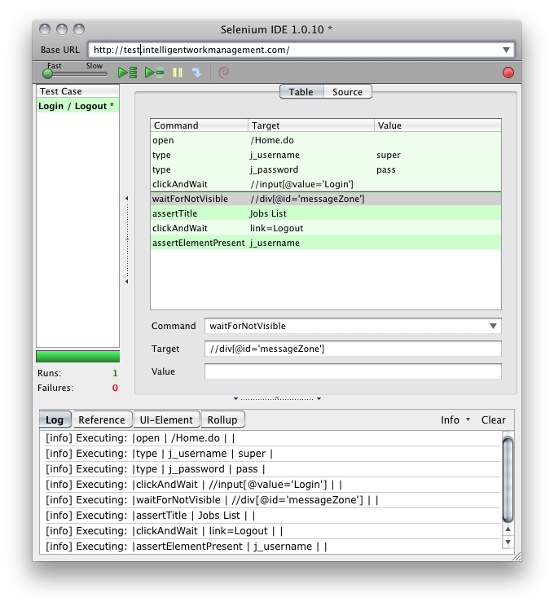
Figure D: Selenium IDE displaying a simple test case.

The Selenium IDE produces Selenium testing scripts in Selenese - a simple list of command, target, and value combinations. Using the IDE, actions, verifications, and assertions can be scripted.

The Selenium IDE also exports scripts to more powerful languages such as Java for closer integration with the language used in the system code. For this project, the test scripts will be developed using the Selenium IDE and then exported to Java for any further adjustments and automated runs on the testing server, via Selenium-RC.

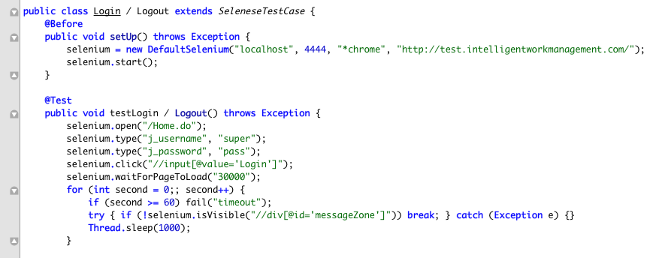

Figure E: Selenium IDE test script exported to Java (partial example)

Test Results within the Selenium IDE

While the test scripts are being developed and manually run using the Selenium IDE, test results are clearly visible after each run from within the IDE itself. Steps that failed to execute, and failed verifications or assertions, are highlighted in the action list.

The Selenium IDE also displays a detailed log that can provide more information on any failures.

Test Results in Continuous Integration Tool

Once a test has been integrated into the build/test environment, the continuous integration tool reports test results after each build and test cycle. These reports are viewable via the continuous integration tool’s web interface. If the continuous integration tool reports a failed test then the test team will create a ticket manually if one does not already exist in the system.

Tools and Environment
The tools used to support the testing approach and individual tests are described in this section. Included are descriptions of the infrastructure and software tools required in the testing effort.

Test Environment
Infrastructure to be built includes the configuration of a testing server and IWM instances. At a minimum, there will be two IWM instances dedicated to testing; a nightly build and a weekly build. In addition to the IWM instances to be used in testing, there will be additional tools installed on the testing server to facilitate build automation, automated test execution, and reporting on test pass or fail. The test team is responsible for the selection and configuration of the hardware and software tools needed to perform these tasks.

Document revision control and defect tracking
Test documentation, including test cases, is created in the Trac wiki directly as wiki pages/elements to facilitate collaboration and revision control on these artifacts. Trac is an enhanced wiki and issue tracking system for software development projects.

The Trac issue tracker provides a configurable defect resolution flow and notification system with report views. Using this functionality, defects can be identified and their status tracked as they flow through the resolution process.

Trac also has integration with Subversion, the revision control system used for both the application code and the test automation scripts. This integration allows for visualization of change sets, links to change sets from wiki pages and tracked issues, and issue updates made automatically from subversion commits. This integration, and Trac’s notification features, allows the testing team and other software tools to rapidly respond to code commits which may require a rebuild and retest.

All of the information stored in Trac is backed up off site daily.

Test Scripting Tool: Selenium
Selenium is a robust set of tools that supports rapid development of test automation for web-based applications. Selenium provides a rich set of testing functions specifically geared to the needs of testing of a web application. These operations are highly flexible, allowing many options for locating UI elements and comparing expected test results against actual application behavior.

One of Selenium’s key features is the support for executing one’s tests on multiple browser platforms.

For this effort, we are using the Selenium IDE and Selenium Remote Control (Selenium-RC).

Selenium IDE
Selenium IDE is an integrated development environment for Selenium scripts. It is implemented as a Firefox extension, and allows for recording, editing, and debugging tests. The Selenium IDE is used to develop the browser automation scripts. These scripts can be exported from Selenese (Selenium’s own scripting language) to Java tests to be run automatically by the Selenium-RC.

Selenium-RC
Selenium-RC (Remote Control) provides an application programming interface and library for each of its supported languages: HTML, Java, C#, Perl, PHP, Python, and Ruby. This ability to use Selenium-RC with a high-level programming language to develop test cases also allows the automated testing to be integrated with a project’s automated build environment.

Selenium-RC is used by the Java tests created with the Selenium IDE. These tests will be called from the Continuous Integration Tool, invoking the tests after each build.

Test Script Revision Control: Subversion
Subversion (SVN) is a software versioning and revision control system, which maintains current and historical versions of files. The Subversion repository is backed up hourly, and backed up off-site daily.

The Selenese scripts and Java tests created by the Selenium IDE are stored and versioned in Subversion, in the QA tree. These artifacts are organized in folders by functional area and test identification number.

Continuous Integration Tool: Hudson
Hudson is used for build automation and test execution. Hudson is a well known continuous integration tool, which can be used to execute and monitor any repeated jobs, but focuses on execution and monitoring of building and testing software projects.

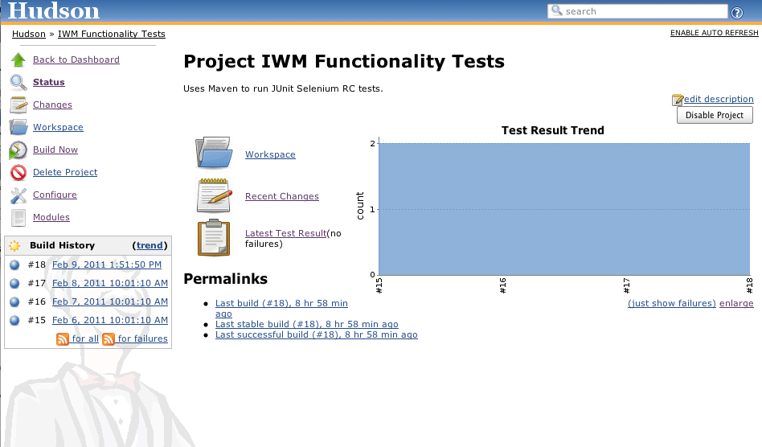
Figure F: Hudson automation dashboard interface

Hudson is configured to execute a build nightly. After the build successfully completes, Hudson checks out the latest QA tree and execute the contained tests against the new build.

Hudson monitors the execution of the build and tests and reports on their success or failure. Hudson notifies the testing team with a report of the outcomes at the completion of the build / test cycle. This report will also be available via a web browser.

Responsibilities

Roles and Responsibilities
The execution of the system test plan is dependent on the contribution of the test team and the development team. Their roles and responsibilities are as follows:

Testing
- Test lead – The test lead is responsible for identifying and creating the system test cases and issuing any resulting tickets or issues through the defect resolution process. The test lead is also responsible creating the test documentation and assuring that all of the information is accurate and up to date, as it remains archived on the wiki.
- Test automation group – The test automation group along with the test lead is also responsible for overseeing the routine testing automation that will run (on a nightly basis) to constantly check for errors.

Development
- Development lead – The development lead is responsible for managing the project plan as well as managing the development team.
- Development team – The development team is responsible for the coding and configuration of the IWM software. The underlying technical responsibilities such as resolving any issues that the test cases may reveal are also the responsibility of the development team. The development team is responsible for constructing a full set of unit test cases for each unit (e.g., class) that is developed. These unit tests will be run automatically nightly as part of the continuous integration activity.

Schedule

Testing Schedule
Test preparation will begin with requirement documentation in March 2011. System testing concludes shortly before the conclusion of the project in August 2011.

Risks and Mitigation

Potential Issue | Potential Risk | Mitigation
Destruction of server hardware. | Primary data loss. | All data is backed up off-site daily. Backups will be restored to new hardware.
Major requirements change after test case production has begun. | Existing test cases have unknown applicability to the new requirements. | Testing will be suspended until test case applicability and updates can be made.
Failure of continuous integration tool. | Nightly automated build and test no longer occurs. | Daily manual build and test execution occurs until the CI tool can be repaired or replaced.
Failure of test automation software. | Builds occur, but automated testing does not. | Manual test execution until test automation tool issues can be corrected.

Approvals

By signing below, within your respective affiliation, you agree to the Sonalysts Contract 2010 TO12 Intelligent Work Management System Test Plan.

Representative of Testing Team:______________________________________

Representative of Testing Team:______________________________________

Representative of Development Team:_________________________________

Representative of Development Team:_________________________________

